**“Once upon a time in Misthaven”**

**PIXEL BROTHERS – DESIGN DOCUMENT**

**Team:**

Thomas – Producer.  
Aaron – Previous Lead Artist/Current Lead Programmer.  
Eric – Previous Lead Programmer/Current Lead Artist.  
Rehan – Lead Story Writer.  
Usman – Game/Level Designer.

**Venue:**

“Once upon a time in Misthaven” is an adventure game that is designed specifically for PC on the Windows console.

**Features:**

* Large, diverse mazes to explore.
* Deep plot that changes your view on the game the more you progress.
* Dodge and evade randomly spawned traps and obstacles.
* Use spells strategically in order to evade the Spirit Guardian.
* Collect currency to buy more power-ups to help aid you in your quest.
* In-game text will make you question your actions.

**Premise:**

Our hero’s hometown has been struck by a curse and everything is not as it seems. The townsfolk have worked together to create a portal to hell and unleash the evil into the world! Only one girl, a special girl, was unaffected by the curse. She ran off to find the source of the portal and stop the curse! You must follow after her and bring her back alive, we could use her power to help us…

**Gameplay:**

Our main character must set out on an adventure to find the girl that managed to escape the curse. She is a threat to the project and must be stopped. Make your way through the mazes of the spirit world in order to find her. This will not be an easy task, as the spirits have placed traps around the mazes that could drain you of your energy. There is also talk of a Spirit Guardian that chases the impure in order to stop them from venturing too far into the spirit world. If you play your cards right, you will find the girl and also learn about the truth. Good luc

**Concept Art:**

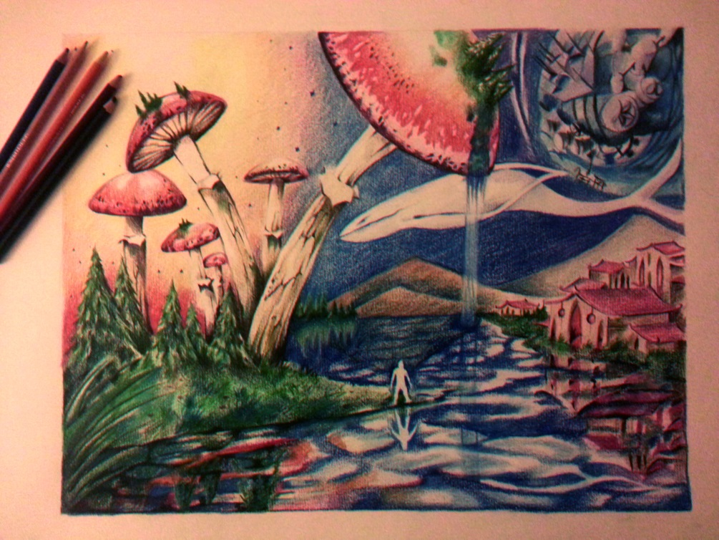

*Swamp Nagrand: when the protagonist steps into the portal he is transported to his majestic place. Only rage fills his heart though has he goes to hunt down the girl.*

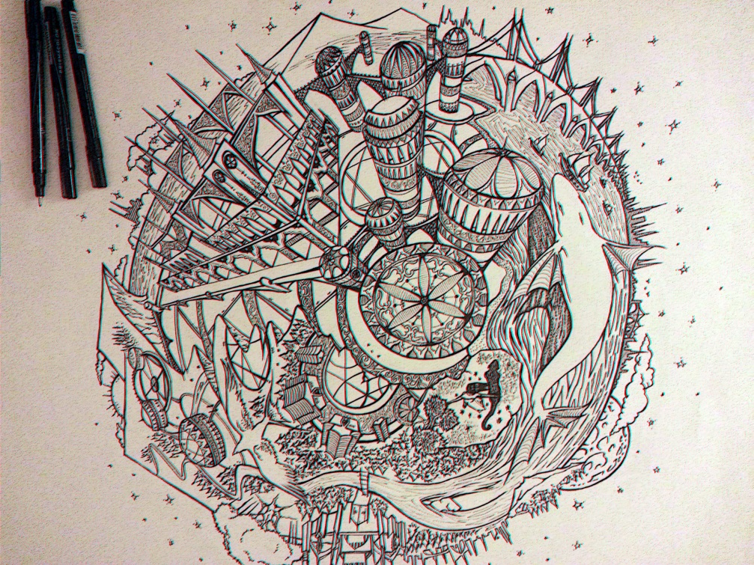

*Misthaven was once a small planet, as the curse took its grip on the land it started to disintegrate; Gravity was destroyed and the land split into several pieces (concept art story)*

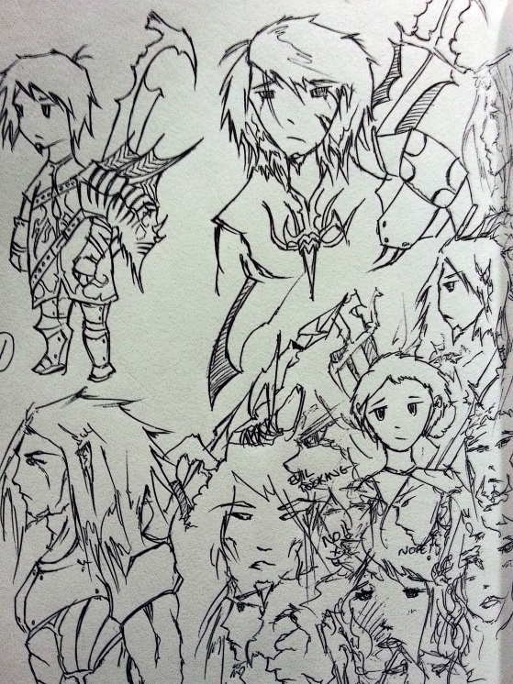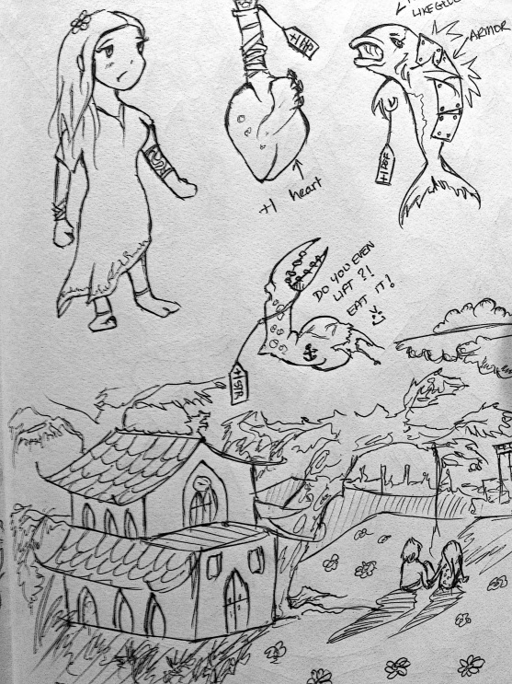

*Rough brainstorming session: Male protagonist on the top left and female protagonist on the top right. We finally went with a cartoony style for the characters.*

**GAME/LEVEL ART**

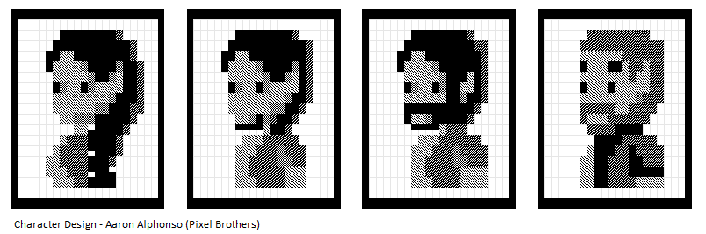

* Female Protagonist.
* Male Protagonist (Main Player).
* Lead Construction worker of the Portal.
* The girl’s Father.

**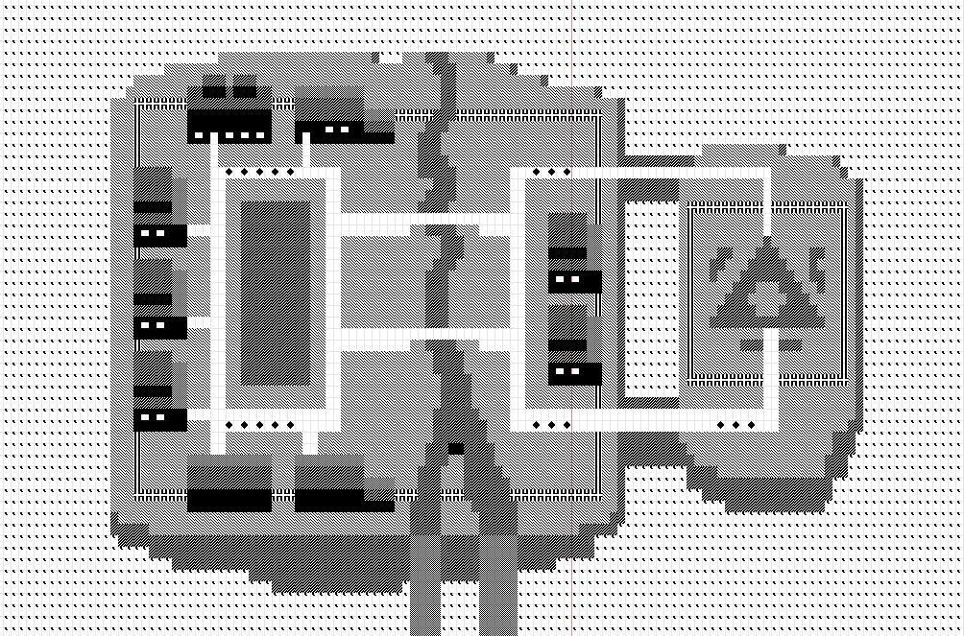***One of the broken landmasses of Misthaven; the main town where the diabolical portal is in construction. All the villagers here are possessed with the curse.*

**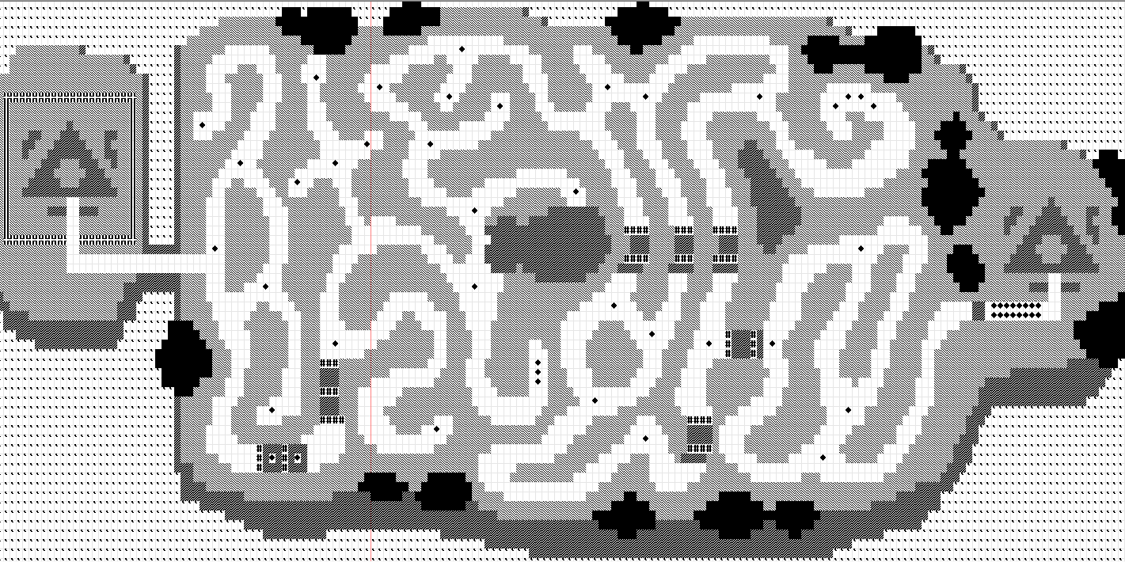***Another broken landmass of Misthaven called Swamp Nagrand. This place, in spite of its luscious beauty, this place is known to be a dangerous place with wild beasts and dormant traps that hunters set up in the past.*